IAD100 series product

IAD100 4S/8S/16S/32S is a high-performance, multi-purpose voice access gateway designed by Shanglu Information Technology Co., Ltd. for small and medium-sized enterprises. The products support data, voice, security, VPN and other functions to meet operators or a virtual operator. The enterprise provides broadband, voice and fax services to users through IP access.

This product uses the standard SIP protocol, complies with the TISPAN/IMS standard, is perfectly compatible with IP PBX, SIP server and carrier IMS/NGN softswitch platform, providing flexible and diverse access methods for operator projects and enterprise converged communications.

* IAD100 4S Front view

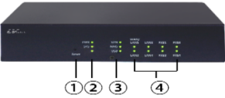

|  |  |
| --- | --- |
| **IAD100 4S Front Indicator Overview** | |
| 1 | Reset button |
| 2 | PWR,SYSTEM indicators |
| 3 | VPN,NMS,USB indicators |
| 4 | WAN/LAN1-LAN4 indicators |

* IAD100 4S Back view

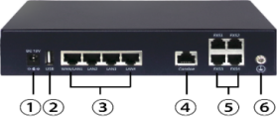

|  |  |
| --- | --- |
| **IAD100 4S Back Indicator Overview** | |
| 1 | DC power ；Input：DC 12V ,1A |
| 2 | USB 2.0； |
| 3 | 1WAN+3LAN；Interface Type： RJ45；  10/100/1000M Network adaptation； |
| 4 | Console;Interface Type： RJ45； |
| 5 | 4*FXS；Interface Type：RJ11； |
| 6 | Ground column |

IAD100 User Selection Guide

Installation precautions

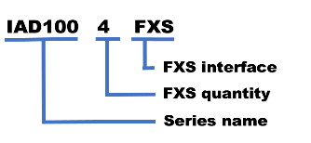

**During the installation and use of the equipment,**

**the following safety recommendations are proposed:**

* The bracket is strong and reliable and avoids shaking. It is recommended to use a standard cabinet;
* Keep the device away from moisture and away from heat sources;
* Please confirm the correct grounding of the equipment;
* Wear an ESD-preventive wrist strap during installation and maintenance, and ensure that the ESD-preventive wrist strap

is in good contact with the skin.

* Do not plug or unplug the interface boards and modules of the electric equipment.
* **Device Installation**

**Screw the equipment to the standard cabinet:**

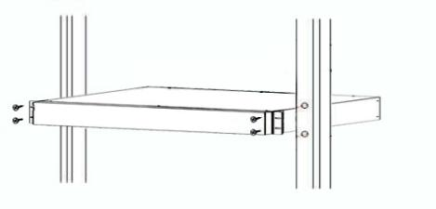

There is a ground yellow terminal at the back of the device,

indicated by a symbol. Ground connection steps are as follows:

* Unscrew the nut on the grounding end of the chassis;
* Put one end of the grounding wire on the grounding post of

the rear panel;

* Put on and tighten the nut;
* Connect the other end of the ground wire to the ground terminal



**LVswitch IAD100 Series**

**Analog FXS gateway equipment**

**Quick Start Guide**

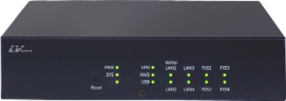



[www.LVswitches.cn](http://www.lvswitches.cn)

Guangdong Shanglu Information technology Co., Ltd

Tel: 86-0757-82288116

Test the SIP server network status

Configure SIP user registration

Phones dialing and answering

pPacking list

Configure Sip server

Web network administrator login

Device power-on self test

Configure the WAN port address

* Path: System >Debug 》ping;

Please configure the test correctly：

* Destination IP address or host name：peer SIP

server address;

* Interface selection：WAN5 ;
* Diagnostics: Can the peer SIP server address be through?

1.Path: Voice set >Voice work 》SIP User Settings;

Please obtain the VOIP account from the VOIP

service provider and configure the following correctly：

* SIP user phone number;
* Authentication username;
* Authentication password;
* Click: Save Settings 》 Apply Setting

Line status：**UP - - - -**Means registration is successful！

Line status：**Unregistering - - -** Means not registered！

Note: If the registration fails, please check whether the primary SIP server address, port number, transmission protocol, authentication user name, and authentication password are configured correctly. Or call the service hotline

at 0757-82288116 to consult the after-sales technician.

Users can access the FXS port through an analog

phone, and can directly make calls and answer calls.

After openning the package,please check the

items inside are the same with the list,if there is any missing,please contact with us

|  |  |
| --- | --- |
| **Name** | **Quantity** |
| IAD100 4S  FXS analog gateway host | 1 |
| Power Cable | 1 |
| Network Cable | 1 |
| Quick Start Guide | 1 |
| Bracket | 2 |

Please login:http://www.LVswitches.cn,

Download Path: Technical Support 》Download 》IAD Voice Gateway 》Download：

《IAD Series User Manual》

Gateway docking flow

Physical connection overview

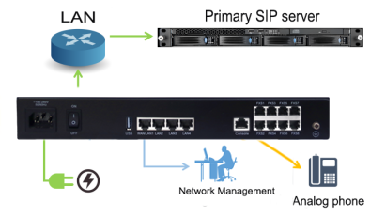

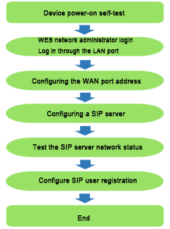

Turn the device power switch “on”； Check if

the power light on the front panel of the device is bright. If the light is on, it indicates that the power supply is connected correctly.

NOTE: After the device is powered on, it will

take 1~2 minutes hardware self-test to run normally. Please be patient. When the running light changes from steady light to blinking, the system startup is completed.

1.Physical connection: The LAN2 port of the IAD100 is directly connected to the PC network port;

1. The PC network port is configured to automatically obtain the IP address mode;
2. The user launches the browser on the PC. In the address bar of the browser, enter http://192.168.200.1 to log in to the device WEB network management.

* Username：admin
* Password：admin

NOTE：The IP address of the PC must be configured with the same network segment as the LAN2 port to access the WEB page.

1. Physical connection：The WAN port of the IAD100 is connected to the enterprise LAN;
2. Path: Network>Basic Setup >WAN setup Connection Type: Select.

* DHCP mode：（Factory default）;
* Static IP mode：Manually configure IPv4, subnet mask, default gateway, IPv4 primary DNS;
* PPPOE mode：Please configure the username and password correctly;
* View WAN Port Address Status Path: Summary >Systems Status >Interface
* Click: Save Settings >Apply Settings

Tips：

Configure the main purpose of the WAN port of the IAD100: Enable the IAD100 gateway to register the peer IP PBX, SIP server, and carrier IMS/NGN on the LAN through the WAN port..

1. Path: Voiceset > Voice work > SIP Server Settings;

Please obtain the main SIP server parameters from the VoIP service provider and configure the following

* Primary SIP registration server IP address；
* The port number；
* Transfer Protocol.

Click: Save Settings 》 Apply Settings